Last time we said some things about different models of rigid analytic geometry and defined the category of adic spaces over a fixed field k. Such objects locally look like affinoid adic spaces over k, whose distinguished opens are rational sets and global sections are given by affinoid k-algebras. Today, our goal will be to define the pro-etale site and start tackling Section 8 of BMS I. To that end, fix a field k and X a locally Noetherian adic space over k (by definition, this means that X is locally given by strongly Noetherian k-algebras). We start with the notion of an etale map of adic spaces.

**The Pro-Etale Site**

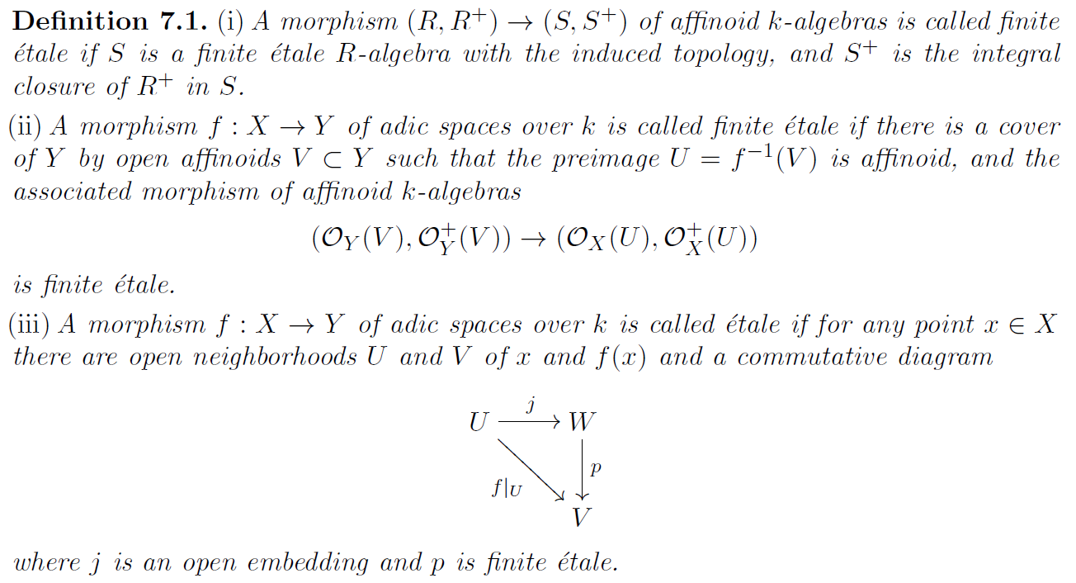

Remarks:

* In condition (i) the topology issue is a little touchy. The morphism from R to S gives S the structure of a finitely generated R-module. There is then a unique way to topologize S so that is it a Hausdorff complete topological R-module having a countable local base at 0. One consequence of this is that morphisms that would be etale in the usual scheme theoretic sense (e.g., an open embedding) need not be etale in our sense. This is so even for inclusions of open discs. Nonetheless, Huber does give a Jacobian-type criterion for etaleness that holds under suitable conditions.
* In condition (ii) one might borrow intuition from scheme theory and define the first listed property as being ***affinoid***. This condition is affinoid local on the target.
* The definition of etale given here is different from the original one given by Huber. We favor this definition since it works well for locally perfectoid adic spaces (i.e., adic spaces whose local sections are perfectoid affinoid k-algebras).

This lets us construct the ***etale site*** of X (ignore the word “perfectoid” in what follows). Of course, one must check that the site axioms actually hold.

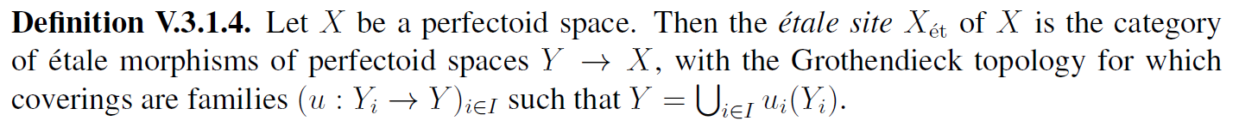

Now that we have the etale site of X, what about the pro-etale site of X? Intuitively, the “open sets” of X_{proet} should be thought of as V\to U\to X with U\to X etale and V\to U an inverse limit of finite etale surjective maps. To rigorously define X_{proet}, we first discuss the notion of a pro-category.

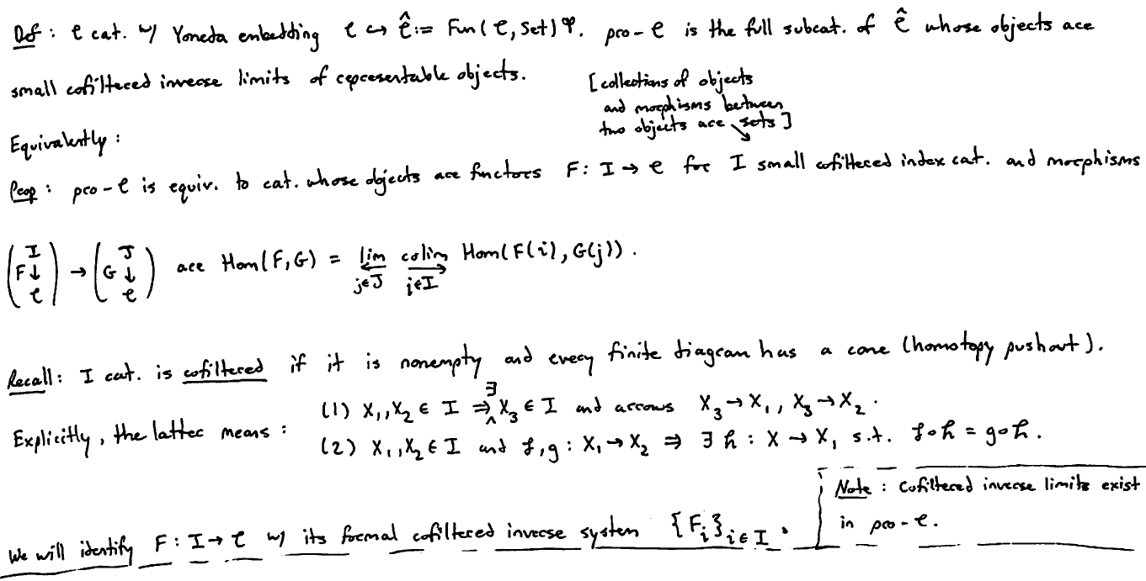

Remarks:

* The definition of \widehat{\mathcal{C}} above is wrong since the op should be on the \mathcal{C} factor.
* It’s worthwhile to consider why the two descriptions of the pro-category are equivalent. In the second description, it’s also important to understand exactly what we mean by a morphism.

This allows us to obtain the category pro-X_{et}.

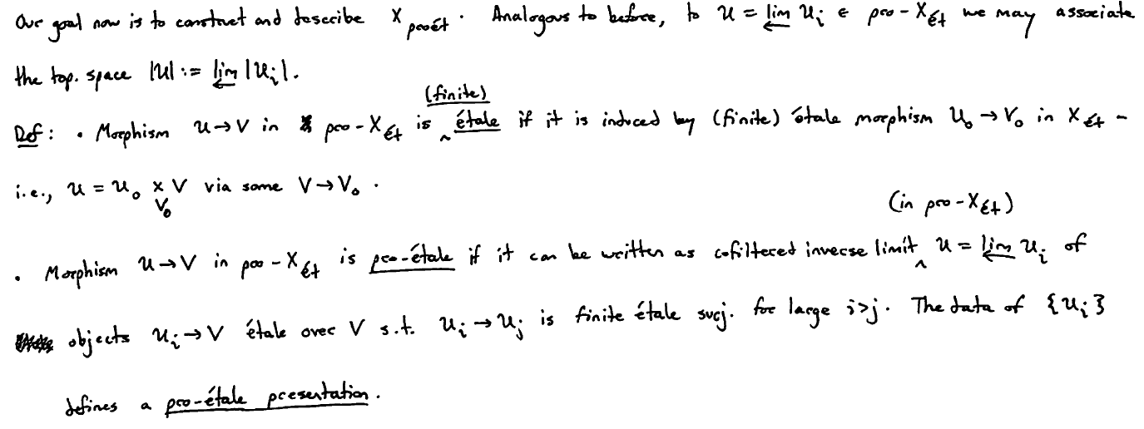

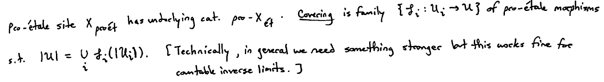

The following shows us that pro-X_{et} and hence also X_{proet} is well-behaved.

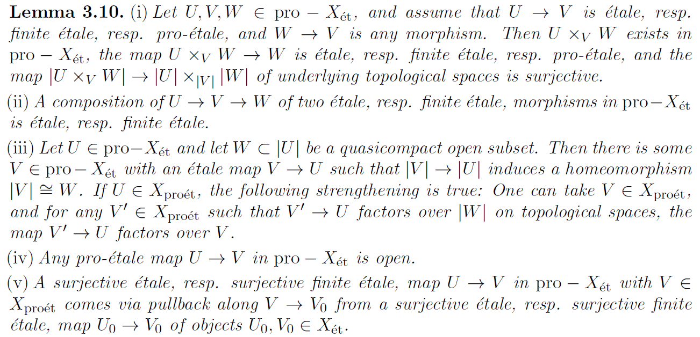

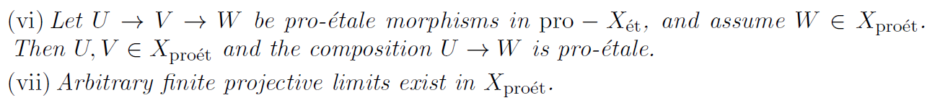

In the case that X is locally Noetherian over Spa(K,K^+) for K a characteristic 0 perfect field, a theorem of Colmez says that affinoid perfectoids form a base for the topology on X_{proet}. What this means is:

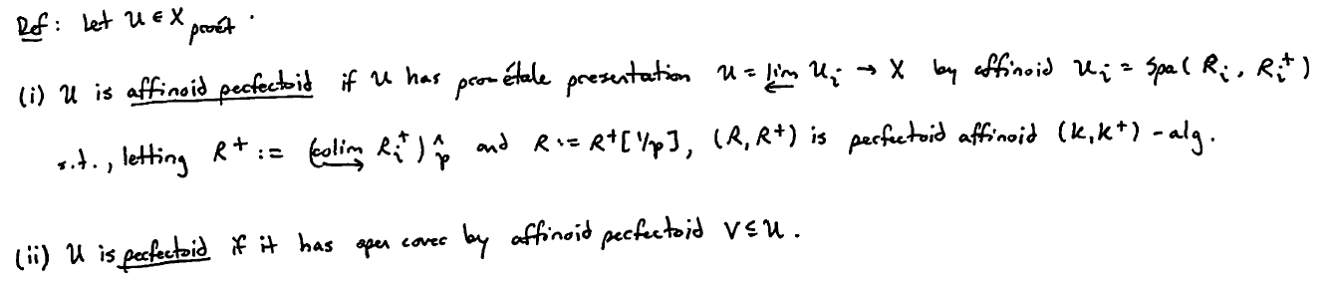

Example: Consider the ***adic torus n-torus (over K)***

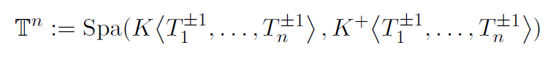

which has an open cover by the affinoid perfectoid space



where for convenience we denote the spaces in this inverse system by \mathbb{T}_m^n.

Remarks:

* The ring K\ip{T^{\pm1}} should be viewed as the ring of convergent bi-infinite power series in T on the unit disc in K.
* In the above we have implicitly embedded X_{et} as a full subcategory of X_{proet}.

We won’t prove Colmez’s theorem, though we will quickly say something about the case where X is smooth over Spa(K,\O). Such X locally admits an etale map to some \mathbb{T}^d which factors as a composite of rational embeddings and finite etale covers (we will encounter a related notion later when we discuss framings). Given r \geq 1, define

X_r:=X\times_{\T^d}\T_r^d

Then, the inverse limit over the X_r is an affinoid perfectoid object in X_{proet}.

**Projection and Sheaves of Interest**

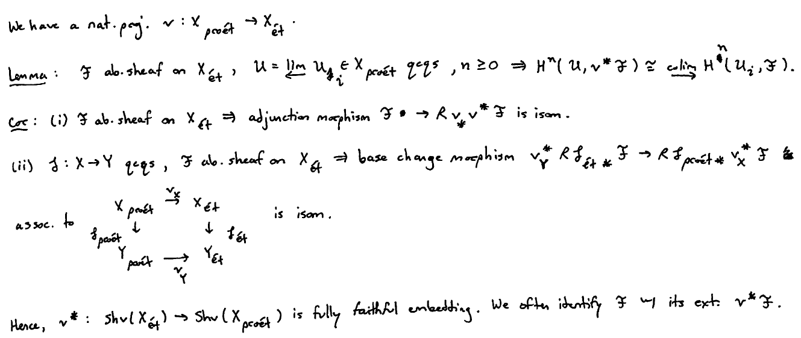

To get an idea of the proof for the lemma, we first assume without loss of generality that \F is injective and X is qcqs. The site X_{proet} has a subsite X_{proetqc} consisting of qc objects which has an equivalent topos to X_{proet} since X is qs. The sheaf \F induces a presheaf on X_{proetqc} which one must check is a sheaf and satisfies the analogous conditions on cohomology. This is done explicitly using Cech cohomology, reducing ultimately to the assumed acyclicity of \F.

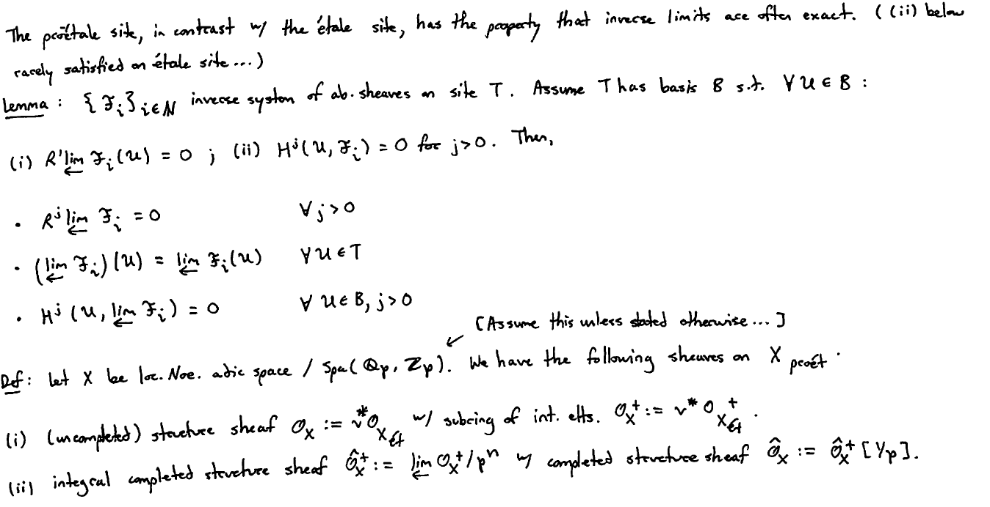

What do these sheaves look like? Recall from last time the following result (which holds for any adic space X thinking about sheaves on the “rational” site of X).

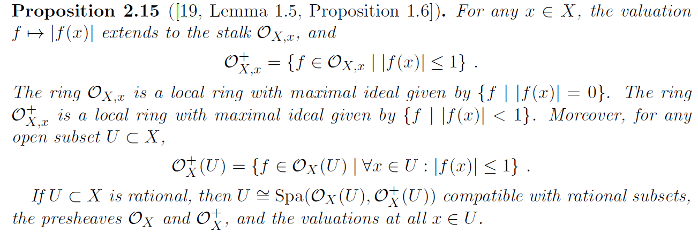

We wish to adapt this to our setting.

